[Q1](https://adapt.in.capgemini.com/mod/vpl/view.php?id=2148" \o "Q1): Find out if the given number is an Armstrong number or not.

CODE :

**import** java.util.Scanner;

**public** **class** ArmstrongNumber {

**public** **static** **void** main(String args[]) {

**int** number = 153;

**int** temp, rem, sum = 0;

System.***out***.println("Enter the number ");

Scanner sc = **new** Scanner(System.***in***);

number = sc.nextInt();

temp = number;

**while**(temp != 0) {

rem = temp % 10;

sum = sum + (rem * rem * rem);

temp = temp / 10;

}

**if**(sum == number)

System.***out***.println("Given number is an armstrong number.");

**else**

System.***out***.println("Given number is not an armstrong number.");

}

}

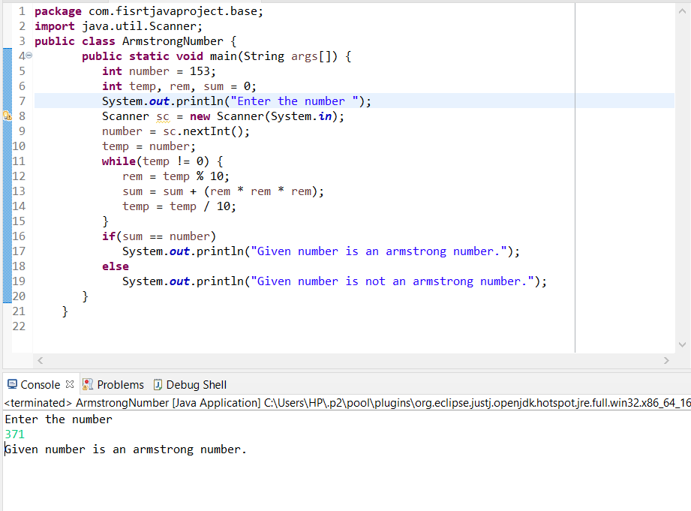

[**Q2**](https://adapt.in.capgemini.com/mod/vpl/view.php?id=2156)**. Find out all the Armstrong numbers falling in the range of 100-999**

CODE :

**import** java.util.Scanner;

**public** **class** JavaExample

{

**public** **static** **void** main(String args[])

{

**int** num, start= 100, end=999, i, rem, temp, counter=0;

**for**(i=start+1; i<end; i++)

{

temp = i;

num = 0;

**while**(temp != 0)

{

rem = temp%10;

num = num + rem*rem*rem;

temp = temp/10;

}

**if**(i == num)

{

**if**(counter == 0)

{

System.***out***.print("Armstrong Numbers Between "+start+" and "+end+": ");

}

System.***out***.print(i + " ");

counter++;

}

}

**if**(counter == 0)

{

System.***out***.print("There is no Armstrong number Between "+start+" and "+end);

}

}

}

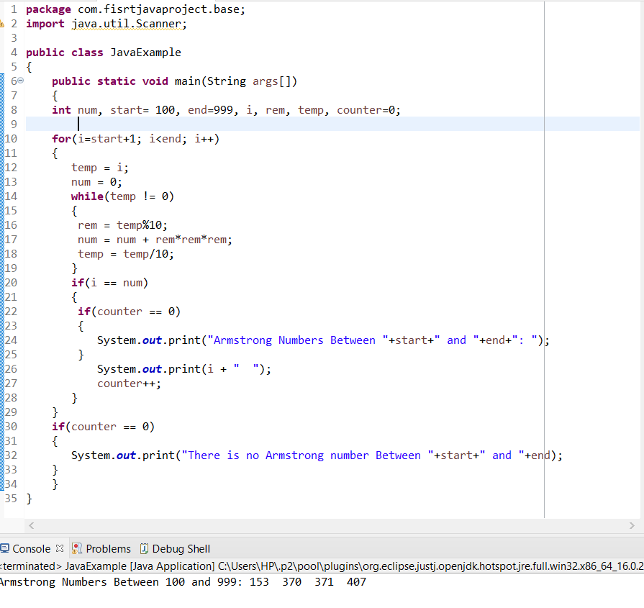

[**Q3**](https://adapt.in.capgemini.com/mod/vpl/view.php?id=2261)**. Find out the simple as well as the compound interest of supplied value**

CODE :

**class** SiCi {

**public** **double** simpleInterest(**double** principalAmount,**int** time,**double** interestRate)

{

**double** SI = (principalAmount *interestRate*time)/100;

**return** SI;

}

**public** **double** compoundInterest(**double** principalAmount1,**int** time1,**double** interestRate1)

{

**double** CI = principalAmount1 *(Math.*pow*((1 + interestRate1 / 100), time1));

**return** CI;

}

}

**public** **class** Assignment1Q3 {

**public** **static** **void** main (String args[]) {

SiCi ci = **new** SiCi();

System.***out***.println(ci.simpleInterest(500000, 5, 7.85));

System.***out***.println(ci.compoundInterest(500000, 5, 7.85));

}

}

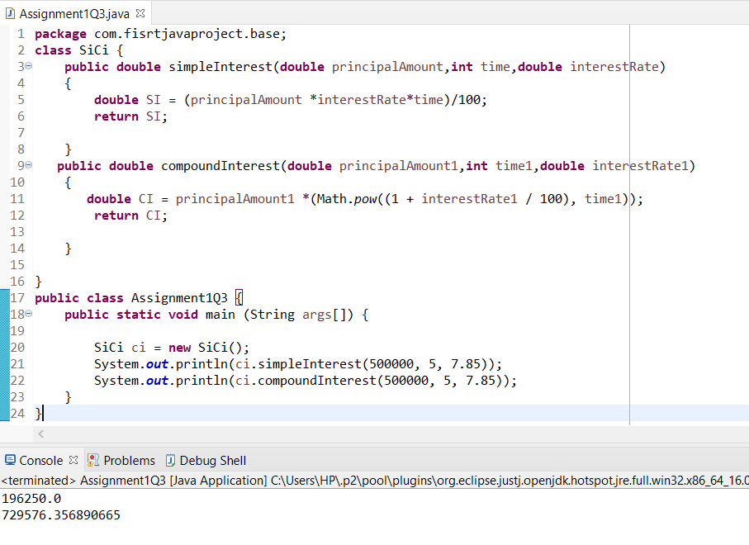

[**Q4**](https://adapt.in.capgemini.com/mod/vpl/view.php?id=2262)**. Supply marks of three subject and declare the result, result declaration is based on below conditions:**

**Condition 1: -All subjects marks is greater than 60 is Passed**

**Condition 2: -Any two subjects marks are greater than 60 is Promoted**

**Condition 3: -Any one subject mark is greater than 60 or all subjects’ marks less than 60 is failed.**

CODE :

**import** java.util.Scanner;

**class** ResultDeclaration{

**public** **static** String declareResults( **double** subject1Marks, **double** subject2Marks, **double** subject3Marks) {

**double** S1M=subject1Marks;

**double** S2M=subject2Marks;

**double** S3M=subject3Marks;

**if**(S1M>=60.0 && S2M>=60.0 && S3M>=60.0)

**return** "Passed";

**else** **if** ((S1M>=60.0 && S2M>=60.0 && S3M<=60 )||(S1M>=60.0 && S2M<=60.0 && S3M>=60.0)||(S1M<=60.0 && S2M>=60.0 && S3M>=60.0))

**return** "Promoted";

**else**

**return** "Failed";

}

}

**public** **class** Assignment1Q4 {

**public** **static** **void** main(String[] args) {

**try**(Scanner sc= **new** Scanner(System.***in***)){

System.***out***.println("Enter Marks in subject 1: ");

**double** subject1Marks =sc.nextDouble();

System.***out***.println("Enter Marks in subject 2: ");

**double** subject2Marks =sc.nextDouble();

System.***out***.println("Enter Marks in subject 3: ");

**double** subject3Marks =sc.nextDouble();

System.***out***.println( ResultDeclaration.*declareResults*(subject1Marks, subject2Marks, subject3Marks));

}

}

}

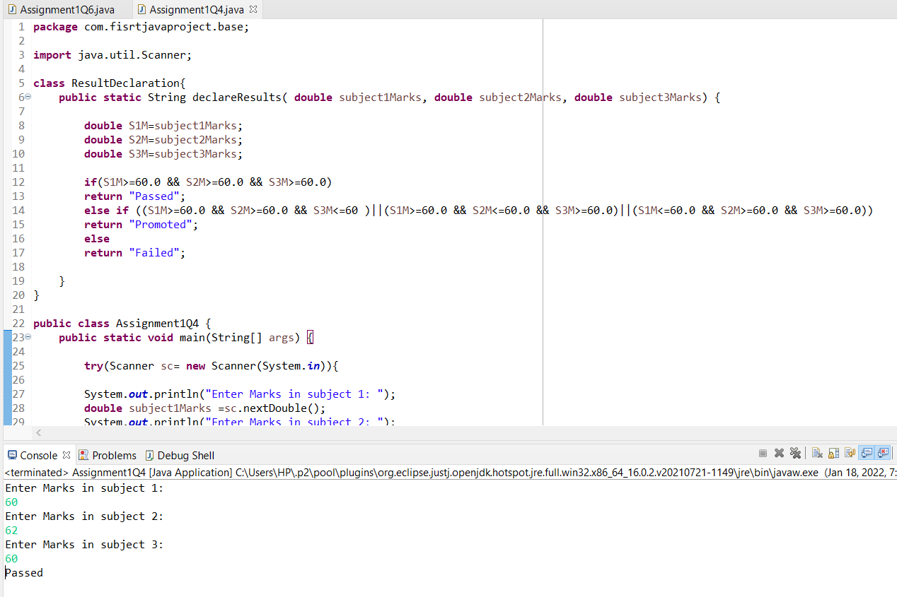

[**Q5**](https://adapt.in.capgemini.com/mod/vpl/view.php?id=2153)**. Calculate the income tax on the basis of following table.**

**Note:-Assume slab is consider for Male, Female as well as Senior citizen**

**Slab                                   Income Range                             Tax payable in Percentage**

**Slab A                               0-1,80,000                                                                  Nil**

**Slab B                               1,81,001-3,00,000                                                    10%**

**Slab C                               3,00,001-5,00,000                                                    20%**

**Slab D                               5,00,001-10,00,000                                                 30%**

**Accept CTC from user and display tax amount**

CODE : **class** TaxAmount{

**public** **double** calculateTaxAmount(**int** ctc)

{

**if**(ctc>=0 && ctc<=180000)

{

System.***out***.println("Your CTC is "+ctc);

System.***out***.println("U belong to SLAB A");

System.***out***.println("U r exempted from paying tax");

}

**else** **if**(ctc>=180001 && ctc<=300000)

{

System.***out***.println("Your CTC is "+ctc);

System.***out***.println("U belong to SLAB B");

System.***out***.println("U have to pay 10% tax");

**double** tax = 0.1*ctc;

System.***out***.println("Your tax amount is "+tax);

}

**else** **if**(ctc>=300001 && ctc<=500000)

{

System.***out***.println("Your CTC is "+ctc);

System.***out***.println("U belong to SLAB C");

System.***out***.println("U have to pay 20% tax");

**double** tax = 0.2*ctc;

System.***out***.println("Your tax amount is "+tax);

}

**else** **if**(ctc>=500001 && ctc<=1000000)

{

System.***out***.println("Your CTC is "+ctc);

System.***out***.println("U belong to SLAB D");

System.***out***.println("U have to pay 30% tax");

**double** tax = 0.3*ctc;

System.***out***.println("Your tax amount is "+tax);

}

**return** 0;

}

}

**public** **class** Assignment1Q5 {

**public** **static** **void** main(String args[])

{

TaxAmount amount = **new** TaxAmount();

System.***out***.println(amount.calculateTaxAmount(500000));

}

}

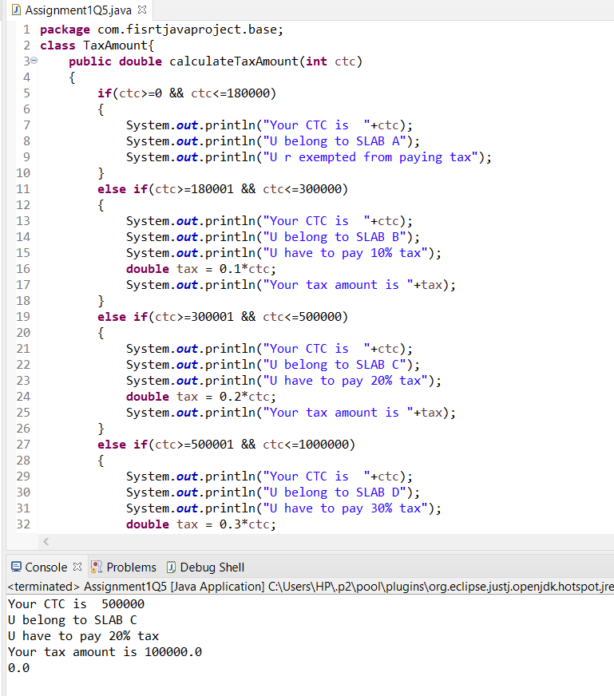

[**Q6**](https://adapt.in.capgemini.com/mod/vpl/view.php?id=2170)**. Consider a CUI based application, where you are asking a user to enter his Login name and password, after entering the valid user-id and password it will print the message “Welcome” along with user name. As per the validation is concerned, the program should keep a track of login attempts. After three attempts a message should be flashed saying “Contact Admin” and the program should terminate.**

**CODE :**

**package** com.fisrtjavaproject.base;

**import** java.util.*;

**public** **class** Assignment1Q6 {

**static** String *userId* = "Ajay";

**static** String *password* = "password";

**static** **boolean** loginuser(String user, String pass) {

**if** (*userId*.equals(user) && *password*.equals(pass))

{

**return** **true**;

}

**else**

{

**return** **false**;

}

}

**public** **static** **void** main() {

**try**(Scanner sc = **new** Scanner(System.***in***)){

String user, pass;

**int** attempt = 0;

**do** {

System.***out***.println("Enter userId : ");

user = sc.next();

System.***out***.println("Password : ");

pass = sc.next();

**boolean** ans =*loginuser*(user, pass);

**if**(ans == **true**) {

System.***out***.println("Welcome Ajay");

**break**;

}

**else** **if**(ans == **false** && attempt <3) {

System.***out***.println("You have entered wrong credentials ,please enter the right credentials.");

attempt +=1;

}

}**while**(attempt != 3);

**if** (attempt >= 3) {

System.***out***.println("\n Contact Admin \n");

}

}

}

}

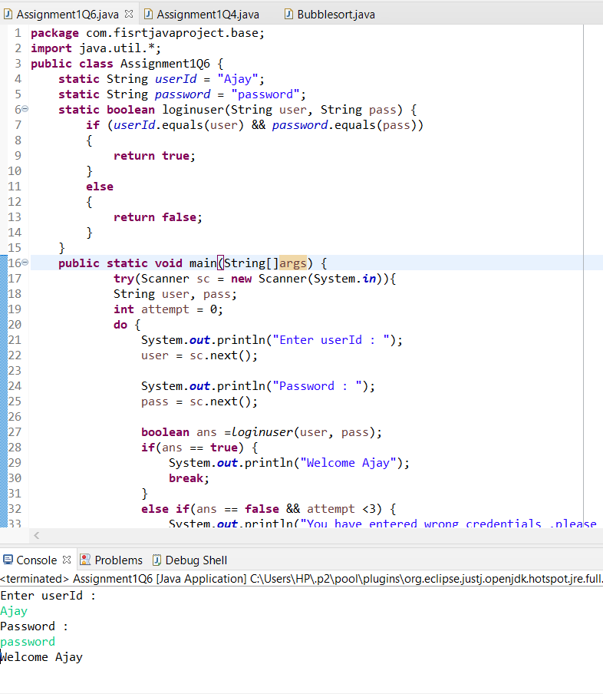

[**Q7**](https://adapt.in.capgemini.com/mod/vpl/view.php?id=2169)**. There is an Array which is of the size 15, which may or may not be sorted. You should write a program to accept a number and search if it in contained in the array**

**Example:**

**5 12 14 6 78 19 1 23 26 35 37 7 52 86 47**

**Value to be search is 19**

CODE :

**package** com.fisrtjavaproject.base;

**import** java.util.Arrays;

**class** Array {

**private** **static** **void** check(**int**[] arr, **int** toCheckValue)

{

**boolean** test = **false**;

**for** (**int** element : arr) {

**if** (element == toCheckValue) {

test = **true**;

**break**;

}

}

System.***out***.println("Is " + toCheckValue+ " present in the array: " + test);

}

**public** **class** Assignment1Q4

{

**public** **static** **void** main(String[] args)

{

**int** arr[] = { 5,12,14,6,78,19,1,23,26,35,37,7,52,86,47 };

**int** toCheckValue = 19;

System.***out***.println("Array: "+ Arrays.*toString*(arr));

*check*(arr, toCheckValue);

}

}

}

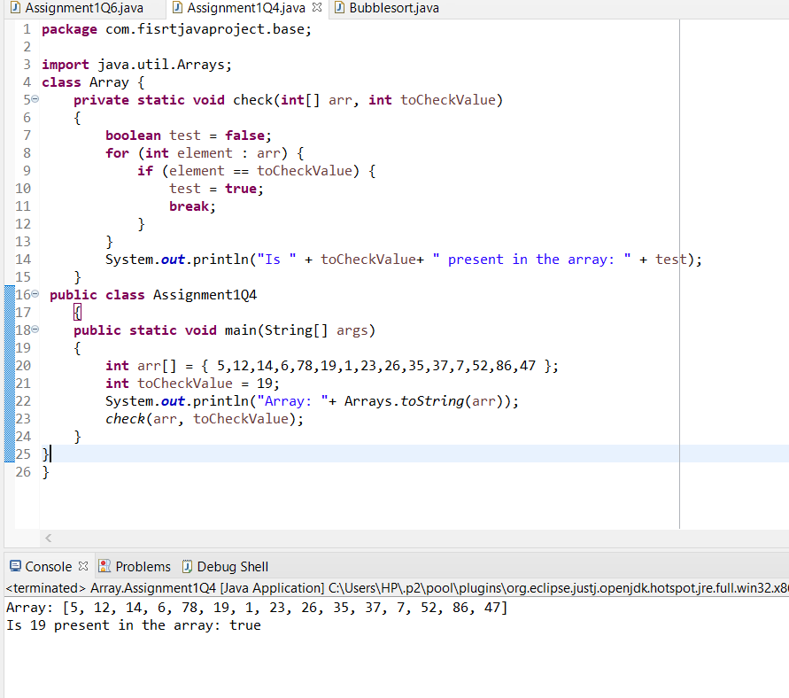

[**Q8**](https://adapt.in.capgemini.com/mod/vpl/view.php?id=2168)**. Using the below table write method apply sorting using Bubble Sort.**

**Example:**

**5 12 14 6 78 19 1 23 26 35 37 7 52 86 47**

**CODE :**

**package** com.fisrtjavaproject.base;

**class** BubbleSort

{

**void** bubbleSort(**int** arr[])

{

**int** n = arr.length;

**for** (**int** i = 0; i < n-1; i++)

**for** (**int** j = 0; j < n-i-1; j++)

**if** (arr[j] > arr[j+1])

{

**int** temp = arr[j];

arr[j] = arr[j+1];

arr[j+1] = temp;

}

}

**void** printArray(**int** arr[])

{

**int** n = arr.length;

**for** (**int** i=0; i<n; ++i)

System.***out***.print(arr[i] + " ");

System.***out***.println();

}

**public** **static** **void** main(String args[])

{

BubbleSort ob = **new** BubbleSort();

**int** arr[] = {5 ,12, 14, 6 ,78,19 ,1 ,23 ,26, 35 ,37, 7, 52 ,86 ,47};

ob.bubbleSort(arr);

System.***out***.println("Sorted array");

ob.printArray(arr);

}

}

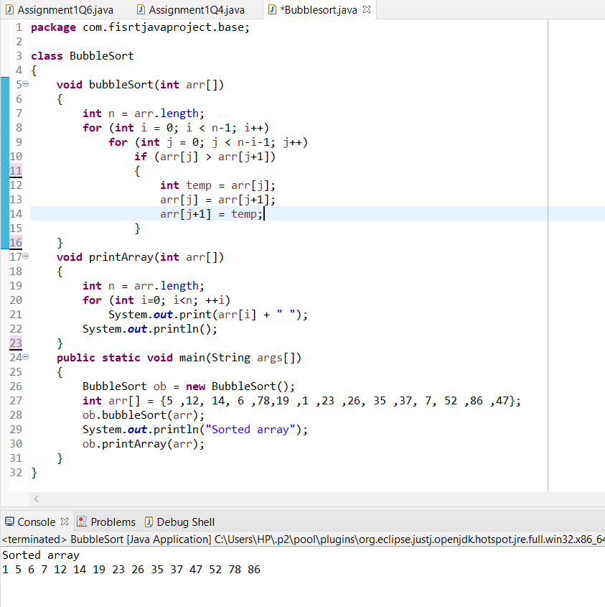

[**Q9**](https://adapt.in.capgemini.com/mod/vpl/view.php?id=2159)**. Accept the marks of three students for the subject say A, B, C. Find the total scored and the average in all the subjects. Also Find the Total and Average scored by students in each respective Subject.**

**Description:-**

Enter the marks of 3 students for subjects A,B,C. Find the total marks secured by respective student in all the subjects and also find the total and average scored by students subject wise.

**Example:-**

              Sample Input:-

                             marks of Student 1 in subjects A,B,C

                                           10 20 30

                             marks of Student 2 in subjects A,B,C

                                           10 20 30

                             marks of Student 3 in subjects A,B,C

                                           10 20 30

**package** com.fisrtjavaproject.base;

**import** java.util.Scanner;

**public** **class** Student {

**static** **int** *subjectA*, *subjectB*, *subjectC*;

**static** **int** studentsTotalMarksInAllSubjects(**int**[] marks) {

**int** sum = 0;

**for** (**int** i = 0; i <9; i++) {

sum += marks[i];

}

**return** sum;

}

**static** **double** studentsAverageMarksInAllSubjects(**int**[] marks) {

**int** sum = *studentsTotalMarksInAllSubjects*(marks);

**int** avg = sum / 3;

**return** avg;

}

**static** **int** subjectATotalByStudents(**int**[] marks) {

**int** sum = 0;

**for** (**int** i = 0; i <9; i += 3) {

sum += marks[i];

}

**return** sum;

}

**static** **int** subjectBTotalByStudents(**int**[] marks) {

**int** sum = 0;

**for** (**int** i = 1; i <9; i += 3) {

sum += marks[i];

}

**return** sum;

}

**static** **int** subjectCTotalByStudents(**int**[] marks) {

**int** sum = 0;

**for** (**int** i = 2; i <9; i += 3) {

sum += marks[i];

}

**return** sum;

}

**static** **double** subjectAAverageByStudents(**int**[] marks) {

**int** sum = *subjectATotalByStudents*(marks);

**double** avg = sum / 3;

**return** avg;

}

**static** **double** subjectBAverageByStudents(**int**[] marks) {

**int** sum = *subjectBTotalByStudents*(marks);

**double** avg = sum / 3;

**return** avg;

}

**static** **double** subjectCAverageByStudents(**int**[] marks) {

**int** sum = *subjectCTotalByStudents*(marks);

**double** avg = sum / 3;

**return** avg;

}

**public** **static** **void** main(String[] args) {

**int**[] Student1 = **new** **int**[3];

**int**[] Student2 = **new** **int**[3];

**int**[] Student3 = **new** **int**[3];

**int**[] marks = **new** **int**[9];

**int** j = 0;

**try** (Scanner sc = **new** Scanner(System.***in***)) {

System.***out***.println("Enter the marks for student 1:");

**for** (**int** i = 0; i <= 2; i++) {

System.***out***.print("Subject : ");

Student1[i] = sc.nextInt();

marks[j] = Student1[i];

j++;

}

System.***out***.println("\nEnter the marks for student 2:");

**for** (**int** i = 0; i <= 2; i++) {

System.***out***.print("Subject : ");

Student2[i] = sc.nextInt();

marks[j] = Student2[i];

j++;

}

System.***out***.println("\nEnter the marks for student 3:");

**for** (**int** i = 0; i <= 2; i++) {

System.***out***.print("Subject : ");

Student3[i] = sc.nextInt();

marks[j] = Student3[i];

j++;

}

System.***out***.println(

"Total marks of all the students in all subjects: " + *studentsTotalMarksInAllSubjects*(marks));

System.***out***.println(

"Average marks of all the students in all subjects: " + *studentsAverageMarksInAllSubjects*(marks));

System.***out***.println(

"Total marks scored by students in subject A: " + *subjectATotalByStudents*(marks));

System.***out***.println(

"Average marks scored by students in subject A: " + *subjectAAverageByStudents*(marks));

System.***out***.println(

"Total marks scored by students in subject B: " + *subjectBTotalByStudents*(marks));

System.***out***.println(

"Average marks scored by students in subject B: " + *subjectBAverageByStudents*(marks));

System.***out***.println(

"Total marks scored by students in subject C: " + *subjectCTotalByStudents*(marks));

System.***out***.println(

"Average marks scored by students in subject C: " + *subjectCAverageByStudents*(marks));

}

}

}

